🏥 Hospital ERP System

1. Problem Statement & Objectives

Problem Statement
Small and medium-sized hospitals often face major inefficiencies in handling administrative, medical, and financial operations. Without a centralized system, hospitals rely on paper-based or disconnected digital tools, leading to:
- Redundant patient data entries
- Appointment mismanagement and scheduling conflicts
- Errors in billing and payment tracking
- Lack of visibility into employee roles and working hours
- Poor medication inventory control
These issues negatively affect operational efficiency, data accuracy, and the quality of patient care.

Objectives
The Hospital ERP System aims to deliver an integrated and user-friendly platform for managing all hospital operations in one place.
Project Objectives:
- Centralize hospital operations — unify patient, billing, HR, and inventory data.
- Enhance service efficiency — automate appointment booking, invoicing, and reporting.
- Ensure data integrity — use MSSQL with enforced foreign key constraints.
- Support role-based access control — secure sensitive medical and financial data.
- Provide actionable insights — generate real-time reports for hospital administration.
- Deliver a scalable architecture — built using .NET Core MVC and MSSQL Server for reliability and future expansion.

2. Use Case Diagram & Descriptions

System Actors
Actor | Role / Responsibility
Admin | Manages users, departments, and system-wide settings
Doctor | Accesses patient medical records, adds diagnoses, and manages treatments
Receptionist | Registers patients, schedules appointments, and issues invoices
Pharmacist | Manages medication inventory and dispensing
Accountant | Handles invoices, payments, and generates financial reports
Patient | (Optional) Views appointment details or invoices via patient portal

Use Case Diagram
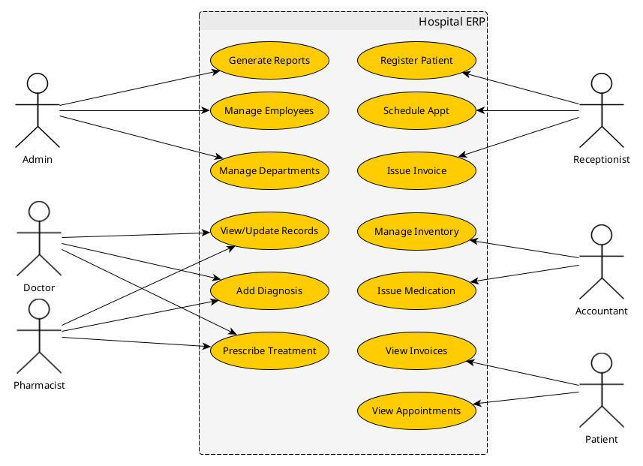

Use Case Descriptions
Use Case | Primary Actor | Description
Register Patient | Receptionist | Create a new patient record with personal and contact details.
Schedule Appointment | Receptionist | Assign a doctor and time for patient consultation.
Record Diagnosis | Doctor | Add or update patient medical diagnosis and link treatment.
Manage Medication Inventory | Pharmacist | Track stock, update quantities, and monitor expiry.
Generate Invoice | Receptionist / Accountant | Create invoices for medical services and medication.
Manage Employees | Admin | Add, edit, or remove hospital employees and define roles.
Generate Reports | Admin / Accountant | Generate daily, monthly, or annual reports for management.

3. Functional & Non-Functional Requirements

Functional Requirements
Module | Requirement
Patient Management | Add, edit, and retrieve patient records with unique ID and linked medical history.
Appointment Management | Schedule, update, cancel, and view appointments between patients and doctors.
Medical Records | Store diagnoses and treatments for each patient, linked with doctor and date.
Billing System | Generate invoices, calculate totals, track payments, and link services and medications.
Inventory Management | Maintain a list of medications, quantities, costs, and expiry dates.
Employee Management | Manage hospital staff with roles, departments, and schedules.
Reports | Generate summaries (e.g., total patients, revenue, medication usage).

Non-Functional Requirements
Category | Description
Performance | The system must respond to user actions within 2 seconds under normal load (≤100 concurrent users).
Scalability | Designed to support future modules (e.g., lab, radiology) with minimal restructuring.
Security | Implement ASP.NET Identity for authentication and role-based authorization for different staff roles.
Data Integrity | MSSQL Server enforces referential integrity via foreign key relationships defined in the ERD.
Availability | The system should operate with at least 99% uptime during business hours.
Maintainability | The MVC pattern separates business logic from UI for easier debugging and updates.
Usability | The system should have an intuitive and clean interface using Razor Pages and Bootstrap.
Backup & Recovery | MSSQL database backups scheduled daily with recovery plans for critical data loss scenarios.
Compatibility | Compatible with modern browsers and deployable on Windows Server environments.

4. Software Architecture

Architecture Overview
The Hospital ERP System is designed using the Model–View–Controller (MVC) architecture pattern within the .NET Core Framework.
It provides a clear separation of concerns, improving maintainability, testability, and scalability.

High-Level Component Architecture
Layer | Description | Technologies
Presentation Layer (View) | User interface for hospital staff to interact with the system — built using Razor Views with Bootstrap for responsive design. | Razor Pages, HTML, CSS, Bootstrap
Controller Layer (Business Logic) | Processes user requests, interacts with models, and returns appropriate views or JSON responses. | ASP.NET Core Controllers
Model Layer (Data Access) | Represents entities and manages data access through Entity Framework Core. | EF Core, LINQ
Database Layer | Stores all hospital data in a relational format according to the ERD. | Microsoft SQL Server
Authentication & Authorization | Manages user login, roles, and permissions. | ASP.NET Core Identity
Reporting & Analytics | Generates reports and analytics dashboards for admins and accountants. | RDLC / FastReport.NET / Razor Reports

Architecture Diagram
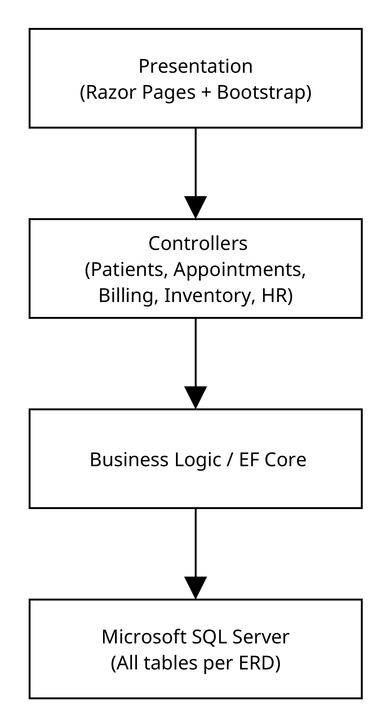

Deployment Details
- Framework: .NET Core MVC 8.0
- Database: Microsoft SQL Server (MSSQL)
- Hosting: IIS or Azure App Service
- ORM: Entity Framework Core (Code-First or Database-First approach)
- Authentication: ASP.NET Core Identity with Role-based Authorization
- Reporting: RDLC / FastReport.NET integrated with Controllers

